Open / Closed Principle
Is it Open or Closed?
This is the first question you should ask yourself after you have finished writing your application module. Beware if the answer is closed. It means you need to take a fresh look at your design. Object Oriented software does not only mean that your application is a combination of several objects but it must satisfy the requirements that the design is flexible, and OPEN for extension. At this point of time, we will define the Open-Closed principle (OCP) formally as:

A software module which should be closed for modification but open for extension.

You may wonder how it is possible to extend an application without modifying it. Precisely, a good OO design gives you this power. Remember, bug fixing your application is not an extension. Think about how Object1 uses Object 2 and Object 2 provides some business logic to Object1. This business logic may be customer specific. To meet different customer needs, if you have to change the business logic embedded in Object 2, your application is violating OCP.

So far so good but the example speaks more than a thousand words and I will present examples to illustrate the points about OCP. If you follow the examples, you should be able to understand and apply OCP in your own application design.

Strong Coupling
What it is? It means that one application module is totally dependent on the implementation of another module. This is the first sign of violation of OCP. Consider this example. You are going to design a banking application where a particular loan request is passed through a LoanValidator to approve the loan request. The LoanValidator looks to see if the balance is above certain values and then approves the request. Given this problem, one guy comes up with the following classes.

The LoanRequestHandler can assess a loan request. This class holds the balance and period of existence for a particular bank account. I have simplified all other features that this class should normally bear to represent a physical bank account. But still this is sufficient to make the point.

Listing 1 LoanRequestHandler.java

public class LoanRequestHandler {

private int balance;
private int period;
/** Creates a new instance of LoanRequestHandler */
public LoanRequestHandler(int balance, int period) {
this.balance = balance;
this.period = period;
}

public void approveLoan(PersonalLoanValidator validator) {
if(validator.isValid(balance))
//sanction the loan
System.out.println("Loan approved...");
else
System.out.println("Sorry not enough balance...");
}
}

This program can tell you if your loan request is approved or not. It uses another object PersonalLoanValidator to decide if the loan request is valid or not. The PersonalLoanValidator just checks to see if the balance is more than 1000 and approves the loan or else rejects it.

Listing 2 PersonalLoanValidator.java

public class PersonalLoanValidator {
/** Creates a new instance of PersonalLoanValidator */
public PersonalLoanValidator() {
}

public boolean isValid(int balance) {
if(balance>1000)
return true;
else
return false;
}
}

Problem
Do you see the problem with the above design? Probably yes. The LoanRequestHandler object is strongly coupled with PersonalLoanValidator object. What happens if the LoanRequestHandler object should be used to verify a business loan. Certainly, your business logic to approve a business loan will be different and PersonalLoanValidator is not capable of handling this business logic.

One solution may to be add another method to the PersonalLoanValidator class to verify the business loan approval process. Also we need to modify the LoanRequestHandler object with an if-else loop to apply different Validator objects for personal loans and business loans. This means every time the bank decides to provide a different type of loan, we need to make change in the LoanRequestHandler and PersonalLoanValidator objects.

This application is certainly not closed for modification. This is where the OCP comes into the picture. This application has violated the OCP and therefore it is not properly designed.

OCP compliant solution
To make the design OCP compliant, we need to make the following changes:

The strong coupling between LoanRequestHandler and any Validator objects should be avoided.
Individual validator objects implementing different business logics for approving a loan request should represent an abstract type and the LoanRequestHandler should use this abstract type rather than any specific sub-type to avoid any strong coupling.
Bearing these facts in mind, we come up with the following design. I will only show the skeleton of the modified design and the code inside each of them remains same as before. Only the design changes, not the implementation.

Listing 3

public class LoanRequestHandler {

private int balance;
private int period;
/** Creates a new instance of LoanRequestHandler */
public LoanRequestHandler(int balance, int period) {
this.balance = balance;
this.period = period;
}

public void approveLoan(Validator validator) {
if(validator.isValid(balance))
//sanction the loan
System.out.println("Loan approved...");
else
System.out.println("Sorry not enough balance...");
}
}

The LoanRequestHandler now uses an interface type of object named Validator, which defines the method for approving the loan. Each individual Validator object will implement this method, with the object specific business logic within the method inherited from the defined Validator interface.

Listing 4

public interface Validator {

public Boolean isValid(int balance);
}

Now each individual Validator object will implement this interface and make use of their individual business logic to approve or reject a loan request. Based on this the PersonalLoanValidator object changes to the following.

Listing 5

public class PersonalLoanValidator implements Validator{

/** Creates a new instance of PersonalLoanValidator */
public PersonalLoanValidator() {
}

public boolean isValid(int balance) {
if(balance>1000)
return true;
else
return false;
}
}

Now we will implement another Validator named BusinessLoanValidator.

public class BusinessLoanValidator implements Validator{
/** Creates a new instance of PersonalLoanValidator */
public PersonalLoanValidator() {
}

public boolean isValid(int balance) {
if(balance>5000)
return true;
else
return false;
}
}

The BusinessLoanValidator only approves the loan request if the balance is more than 5000, whereas the PersonalLoanValidator will approve it if the balance is more than 1000. But the LoanRequestHandler remains unaffected by this change in the business logic change. So long it is supplied the correct Validator, it will operate correctly.

Clearly, this is a better design. Any new loan type can be handled by adding a new XXXValidator object, implementing the Validator interface. This is OCP compliant solution.

Liskov's Substitution Principle
by Samudra Gupta
That Java is an Object Oriented language does not necessarily mean that the code written in Java is always Object Oriented. If this statement surprises you, this series is for you. In this series, I will try to demonstrate some design aspects, both good and bad, that are the key to well written software in Java. The first of these is the Liskov’s Substitution Principle (LSP), which will lead to the Design by Contract and Dependency Inversion Principle. We will then see how all of them conform to one most vital principle of OO design, the Open-Closed Principle.

Liskov’s Substitution Principle
The Liskov’s Substitution Principle provides a guideline to sub-typing any existing type. Stated formally it reads: If for each object o1 of type S there is an object o2 of type T such that for all programs P defined in terms of T, the behaviour of P is unchanged when o1 is substituted for o2 then S is a subtype of T.
In a simpler term, if a program module is using the reference of a Base class, then it should be able to replace the Base class with a Derived class without affecting the functioning of the program module.

An example
When I was in the beginning of my IT career, I was working on a banking project and I was asked to design an account-handling module. To simplify the scenario, let us assume that I had two types of accounts to handle. One is the "Current Account" and the other is a special type of current account with a better interest rate, but with some restrictions that the account cannot be closed before a certain time period. Having done the preliminary analysis, I decided to come up with two account objects "CurrentAccount" and "SpecialCurrentAccount," and also decided to write another class that would offer the interfaces to operate on these "XXXAccount" objects. I also analysed that the "SpecialCurrentAccount" and "CurrentAccount" share lot in common. Delighted with such a straightforward relationship, I came up with the following class diagram. The SpecialCurrentAccount is a sub-type of the CurrentAccount.
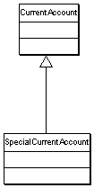
The program specification for the module specified the following constraints.
- The closing of Current Account should check for a balance greater than zero. If satisfied, proceed to close the account.
- The closing of Special Current Account should check for a balance greater than zero and also that the minimum period for the account is covered. If satisfied, proceed to close the account.
From the above specification and my own class diagram, I decided that I will override a closeAccount() method in the derived SpecialAccount class. The following programs CurrentAccount.java (Listing 1) and SpecialCurrentAccount.java (Listing 2) describe the designed classes.
/*
* Account.java
*
*/

package sam.oo.bad;

public class CurrentAccount {

/** Holds value of property balance. */
protected int balance;

/** Holds value of property period. */
protected int period;

/** Creates a new instance of Account */
public CurrentAccount(int balance, int period) {
this.balance = balance;
this.period = period;
}

/**
* open a current account with the given balance
*/
public boolean openAccount(int balance)
{
this.balance = balance;
return true;
}

/**
*closes the account
*/
public boolean closeAccount()
{
if(balance >0)
return true;
else
return false;
}

/** Getter for property balance.
* @return Value of property balance.
*/
public int getBalance() {
return this.balance;
}

/** Setter for property balance.
* @param balance New value of property balance.
*/
public void setBalance(int balance) {
this.balance = balance;
}

/** Getter for property period.
* @return Value of property period.
*/
public int getPeriod() {
return this.period;
}

/** Setter for property period.
* @param period New value of property period.
*/
public void setPeriod(int period) {
this.period = period;
}

}
Listing 1 CurrentAccount.java
Here is the code for the SpecialCurrentAccount.
/*
* SpecialCurrentAccount.java
*
*/

package sam.oo.bad;

public class SpecialCurrentAccount extends CurrentAccount{

/** Holds value of property defaultPeriod. */
private int defaultPeriod;

/** Creates a new instance of SavingsAccount */
public SpecialCurrentAccount(int balance, int period) {
super(balance, period);
}

public boolean closeAccount()
{
if(balance>0 && period>defaultPeriod)
return true;
else
return false;
}

/** Getter for property defaultPeriod.
* @return Value of property defaultPeriod.
*/
public int getDefaultPeriod() {
return this.defaultPeriod;
}

/** Setter for property defaultPeriod.
* @param defaultPeriod New value of property defaultPeriod.
*/
public void setDefaultPeriod(int defaultPeriod) {
this.defaultPeriod = defaultPeriod;
}

}

Listing 2 SpecialCurrentAccount.java
Also I decided to offer an interface through another class to operate on these account objects, which looked like:
public void closeAnAccount(CurrentAccount ac)
{
System.out.println("Account close result: "+ac.closeAccount());
}

/**
* @param args the command line arguments
*/
public static void main(String[] args) {
AccountTest test = new AccountTest();

CurrentAccount ac = new CurrentAccount(100,2);
SpecialCurrentAccount sac = new SpecialCurrentAccount(200,5);

test.closeAnAccount(ac);
test.closeAnAccount(sac);

}
Everything went fine, and I was happy, until a user of this module discovered an unexpected behaviour with the system. When he tried to do the above, the result was contrary to his expectation.
Account close result: true
Account close result: false
The closing of a SpecialCurrentAccount object failed and the user has no clue why, without looking into the source code of the SpecialCurrentAccount class. But looking into interface closeAnAccount(CurrrentAccount), he is justified to make an assumption that any type of CurrentAccount object will behave in a similar manner. But in reality it did not. That made me think a while and I came to the following conclusions:
- While designing the class hierarchy I have violated the LSP.
- My overridden method closeAccount() in the derived class SpecialCurrentAccount had broken the module by not allowing a base class CurrentAccount object to be replaced by derived class object SpecialCurrentAcount.
- By creating the above hierarchy I had expected the user to know about the internal implementation of both the account classes before he can be assured of a guaranteed behaviour of the module. Clearly, this is not desirable and often he might not have access to the source code to do so.

Design by Contract
The above discussion leads us to the discussion of the Design by Contract principle. In Design by Contract, each method in a class can have a pre-condition and a post-condition attached to it. The pre-condition defines the criteria to be met before the method offers a certain behaviour and the post-condition is the state or behaviour offered by the method once the pre-conditions are met. Following that, if we note down the pre-conditions and post-conditions followed by the CurrentAccount and the SpecialCurrentAccount classes, they will look like the following:
CurrentAccount.java

/**
* pre condition: the balance >0
* post-condition: the account is closed
**/
public boolean closeAccount()

SpecialCurrentAccount.java

/**
* pre condition: the balance >0
* the period > default period
* post condition: the account is closed
**/
public boolean closeAccount();
The pre-condition set in the sub-type SpecialCurrentAccount contains more conditions than the base-type CurrentAccount. This is against the Design by Contract principle. According to the Design by Contract:
A sub-type can only have weaker pre-conditions and stronger post-conditions than its base class.
Clearly, my previous design violated the Design by Contract principle.Having these facts in mind, I had a clear idea what was going wrong and approached a better LSP and Design by Contract compliant solution.

LSP compliant solution
One of the main lessons I learned is that sub-typing needs to be done with respect to the behaviour of the types and not with respect to the data only. In this aspect, the SpecialCurrentAccount IS NOT A CurrentAccount. A banker will shout at me for sure if I say this to him. But for you the intelligent programmers this would make sense. This is because they do not exhibit the same behaviour against the same message. I decided to break the hierarchy and come up with is new design with Account as an abstract base type and CurrentAccount and SpecialCurrentAccount as its sub-types.
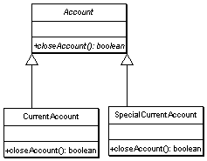
The abstract Account class declares an abstract method closeAccount(), which is implemented by both CurrentAccount and SpecialCurrentAccount. I have now changed the interface class to accept an Account type of Object as opposed a particular type of Account Object. The new interface class looked like this.
public boolean closeAnAccount(Account ac)
With this hierarchy, what may surprise you is that we have not changed the implementation of the closeAccount() method in any of the classes. The pre-conditions and the post-conditions remain the same. But in essence, what has happened is that the user will not make any assumption about the behaviour of the account object he is dealing with. This makes the module more maintainable and reusable in the sense that now it is very easy to add another type of account which may impose some other pre-condition and post-condition without breaking the LSP and Design by Contract.

No overriding!!!
It may seem from the above discussion that overriding is the main problem with LSP and in that case inheritance makes no sense. To some extent, it is puzzling but always keep the Design by Contract principle in mind before you override. If you are unable to comply with the same, then it might be worth revisiting your class diagrams. Always make sure that the derived class must enforce less strict pre-conditions while overriding any base class method. Try to think about the situation on your own and surely you will come up with some logic why LSP is so important for a good OO design.

Dependency Inversion Principle
The OCP is the guiding principle for good Object-Oriented design. It is easy and it is difficult. The main problem is how you look at your design. The design typically has two aspects with it. One, you design an application module to make it work and second, you need to take care whether your design, and thereby your application, module is reusable, flexible and robust.
The OCP tells you that the software module should be open for extension but closed for modification. As you might have already started thinking, this is a very high level statement and the real problem is how to achieve this. Well, it comes through practice, experience and constant inspection of any piece of design, understanding that how it performs and works tackles with the expanding requirements of the application. But even though you are a new designer, you can follow certain principles to make sure that your design is a good one.
One of these principles is the Dependency Inversion Principle, which helps you make your design OCP compliant. Formally stated, the principle makes two points:
- High level modules should not depend upon low level modules. Both should depend upon abstractions
- Abstractions should not depend upon details. Details should depend upon abstractions.
What this means? Think about a typical software design process. You typically start with high-level modules. For example, if you are designing a module, which collects data from a data source and writes to a database, you will try to break down the architecture in the following way.
- There is a component which accepts certain objects and writes data to the database
- There is a component which reads data from a certain data source and creates certain suitable objects for the data writing component.
Look at it like this, your idea started from the point that you need to write some data to the database and then you think about getting the data in an acceptable format. There is nothing wrong in this process. This is what your application looks like from the high-level. But there is a danger if you fail to transform your thinking into a right design.
Consider, given the above problem, you come up with the following design in Figure 1.
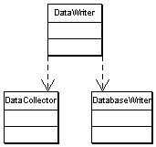
Figure 1 A traditional design example
The DataWriter class uses the DataCollector class. The DataCollector class is responsible for collecting the data from some data source and passing the required object to the DataWriter class. The DataWriter class in turn accepts the passed object and uses another class DatabaseWriter to write data to the database.
Assuming this architecture, the pseudo-code for the above classes may look like this.
Listing 6 DataCollector.java
public class DataCollector
{
public void collectData(String source) {

//collect the data from source, let us say String data

//initialise a DataWriter object
DataWriter writer = new DataWriter();

//ask the writer object to write the data
writer.writeData(the collected data);
}
}
The pseudo-code for the DataWriter class may look like this.
Listing 7 DataWriter.java
public class DataWriter {

public void writeData(the data) {
//write the data to the database
DatabaseWriter dw = new DatabaseWriter();
dw.writeToDB(params);
}
}
The pseudo code for the DatabaseWriter can in turn look like this.
Listing 8 DatabaseWriter.java
public class DatabaseWriter
{

public void writeToDB(params) {

//write physically to the database
}
}
Look at this design, implement it and your application will run fine. Now there is a problem, your high level component is dependent on the details of the low level implementation. Clearly, it is tied to the implementation of the DatabaseWriter object. This makes your design inflexible. Really, what you want your DataWriter object to be able to write to any destination. This gives you the ability to reuse your DataWriter class to write data to any other destination should the application require it in the future.
One solution may be to put an if-else loop within the DataWriter, so that it can decide which destination to write to. We have discussed in OCP that this is the point not at all desirable. This makes your software open for modification. A better approach of thinking would be:
"We need to make DataWriter object independent of any specific destination."
How can we do this? Abstraction is the answer. This is the key for flexible design. Make the abstractions depend on each other, not the concrete implementations. Look at the following modified design in Figure 2.
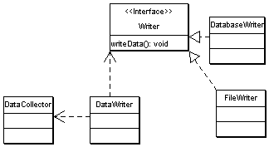
Figure 2 A better design example
In this design, we have abstracted the implementation of the data writing components. Now the DataWriter class uses the <<interface>> Writer. There are two concrete implementations of this interface viz. DatabaseWriter and FleWriter. You can pass any of the implementations depending on the requirement. Notice, that this design is flexible because you can add any other Writer to the application structure should it be required.
All said and done, why is it called Dependency Inversion Principle? The answer is again in thought thinking patterns. In the traditional approach, we start thinking from the high-level modules and cascade down to the lower levels. For example, we initially thought, we need an object to write data to the database and then created another object to write the data to the database and strongly coupled the high-level writer object to the low-level database writer object. This led to the bad design.
In Dependency Inversion Principle, we started thinking from the low-level modules. We identified that we may need to write to different destinations and thereby may need many Writer objects in the system. But all of them are writing data to somewhere and abstracted it to the Writer object. Then we associated this abstraction to the high-level module, the DataWriter.
You might at this point question and might have truly experienced that designing with abstraction is sometimes overkill. In many cases, the requirement is rigid and unlikely to change too often. It is a trade-off, as to how far we go and how much time we spend on a good design. It may be quite important to get a reasonable designs out to the developers and let the project get on. True, but again if you look at any project, you will often find distinct layers of application components. They may typically be like this:
- High-level policy objects holding different piece of business logic or common functionality across different modules.
- The Policy level components use some middle layer objects to perform different business level operations such as sending messages to other components, writing data to some data source etc.
- The lowest-level objects are Utility objects, which hold the concrete implementation of different operations.
In my opinion, for a reasonable design, you need to concentrate on the Policy level objects. It is important to get them well designed as a policy can be reused by many other applications. The rest of the layers can be left for now if you have run out of time and resource.

Conclusion
Hope you have understood the power of OO designs following the OCP and DIP. It might need some practice in the initial days of design but once you get it by heart, this becomes easy. The important thing is to consider the alternate scenarios that can arise to break your application design. If you find them, try to see if your design can handle them. If not, think about these principles and you might see some light.

Interface Segregation Principle
Previous examples and articles have shown that interface-based designs are much more effective in making a software module flexible. In the Java language, interface provides a way of inheriting the methods, without inheriting the implementation. The alternative is the inheritance mechanism (used by the extends keyword in Java), where you inherit all the public and protected method implementations by default. The previous choice between inheritance or composition is a delicate one. Remember that the interface-based composition gives you more flexibility in terms of design.
While designing with interfaces is a grand idea, care should be taken when designing the interfaces themselves. In Java, interface is the way to guarantee certain behaviors through the objects that implement the interface. The problem comes when multiple objects implement the same interface. The Interface Segregation Principle (ISP) helps you to achieve appropriate separation of interfaces. Formally stated, the ISP reads:
Many specific interfaces are better than a single general interface.
Why is this? Look at the following example. Imagine that in your application you are required to write some Data Access Objects (DAO). These data objects should support a variety of data sources. Let's consider that the two main data sources are file and database. You must be careful enough to come up with an interface-based design, where the implementation of data access can be varied without affecting the client code using your DAO object. The following design is a good example of the above requirements (Figure 3).
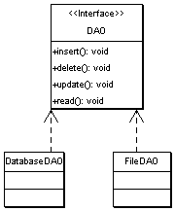
Figure 3: The initial DAO class hierarchy
There's another aspect that needs be to considered. What happens if the data source is read-only? The methods for inserting and updating data are not needed. On the other hand, if the DAO object should implement the DAO interface, it will have to provide a null implementation for those methods defined in the interface. This is still acceptable, but the design is gradually going wrong. What if there is a need to rotate the file data source to a different file once a certain amount of data has been written to the file? That will require a separate method to add to the DAO interface. This is just to add the flexibility to the clients using this FileDAO object to enable them to choose either the normal append feature to the file data source or to make use of the improved file rotation feature.
With the DatabaseDAO implementation now broken, we'll need to change it, to provide a null implementation of the new method added to the interface. This is against the Open-Closed Principle.
So, what went wrong? In the basic design, the fact that the file data access operation and database access operation can differ fundamentally must be considered. We defined the behaviors for both the data access operation, and the database access operation together in a single interface. This caused problems at a later stage in the development. It is not necessary to be a guru in Object Oriented System Design, to solve this problem nor is vast experience in designing software applications needed. What is necessary is to think of interfaces as the behaviors to be provided through particular objects. If two or more objects implementing the interface depict different sets of behaviors, then they probably cannot subscribe to a single interface.
When a single interface is designed to support different groups of behaviors, they are, by virtue, inherently poorly designed, and are called Fat interfaces. They are called Fat because they grow enormously with each additional function required by clients using that interface.
Thus, for the problem with the Data Access Objects, follow the Interface Segregation Principle, and separate the interfaces based on the behaviors. The database access classes and file access classes should subscribe to two separate interfaces. The following design is obtained by applying the Interface Segregation Principle (Figure 4).
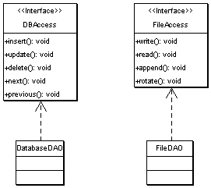
Figure 4: The final DAO class hierarchy
With this design, the Fat interface symptom is avoided and the interfaces clearly delineate their intended purpose. If any imaginary data access object requires a combination of operations defined in both of these interfaces, they will be able to do so by implementing both the interfaces.

Conclusion
This article summarizes the concepts of the Composite Reuse Principle and Interface Segregation Principle. The first principle addresses a good interface-based system design, while the second addresses the issues of designing interfaces which are more cohesive, grouped on the behaviors they support.
This ties up the loose ends in our discussion about the design of class structure. In my next article, I will explore how package structure is as important as class structures, and examine a few principles governing proper package structure.

Composite Reuse Principle
The Composite Reuse Principle (CRP) is a source of never-ending debate amongst designers. The basic idea of this principle is to favor composition over inheritance as a way of achieving polymorphism.
Polymorphism, in Object Oriented terminology, means that any particular class can exist as multiple distinct sub-classes (sub-types). The following is an example of polymorphism:
abstract class Animal {
abstract void talk();
}

Class Dog extends Animal {
public void talk() {
System.out.println("Scooby dooby Doo");
}
}

Class Cat extends Animal {
public void talk() {
System.out.println("Meow....");
}
}

Animal is the super class, and it can exist in the form of either a Dog or a Cat. When objects exist in the real world, they exhibit some behavior to the external world. Thus, the Dog and Cat objects expose the behavior of talking and, as they talk differently, they are polymorphic.
The above example demonstrates how polymorphism can easily be achieved with inheritance. However, inheritance based polymorphism often is ineffective, as an explosion of subtypes may cause the system to run out of flexibility. Take a look at the following example:
Imagine that you have been assigned the task of designing a payroll system for an organization. As Christmas is near, your first job is to make some provision for employee bonus payments . The company has three types of employees: Permanent, Temporary and Part-time.
In your initial design, you have considered each employee to be a polymorph of the base type Employee. You have also determined that the bonus for all employees is calculated in a similar manner and defined the calculateBonus() method in the Employee class. The other operations, such as leave and insurance premium calculations, are specific to the type of Employee. Thus those methods are declared as abstract in the super class and provided the implementation in the specific Employee classes. The initial design is shown in Figure 1.
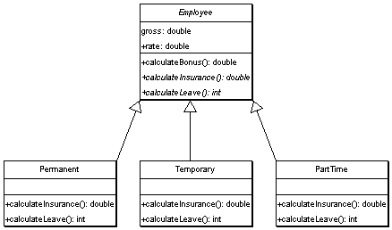
Figure 1: The initial Employee class hierarchy
Later, the project manager changed the rate at which part-time employee bonuses should be calculated. To accomplish that, simply override the calculateBonus() method in the PartTime class.
The manager is impressed. Then he asks that the company consultants get bonuses, calculated at the same rate as part-time employees.
- You could create a new class called Consultant and make it a sub-class of PartTime to inherit the calculateBonus() implementation. However, this causes a problem with the class hierarchy, because Consultants are also Employees. The class hierarchy will always say that Consultants are part time employees, which they aren't. In addition, if on a future date, the Consultant receives a Permanent employee bonus, the hierarchy will not withstand the change.
- Another possibility would be to override the calculateBonus() method in the Consultant class, and copy the same implementation of PartTime class there. However, duplicate code is not the reusability we desire.
The original class structure is highly limiting when new parameters are added. Lets now examine the following solution and explanation.
To date, we've made a fundamental assumption that the bonus calculation is a frozen arithmetic function and pushed it to the super class. In reality, the calculation of bonus can change algorithms more frequently, and each type of employee can have a unique bonus calculation algorithm. Inheritance is only applicable in the context of a generalized relationship where the sub-type is a super-type. Or, in other words, there is an ISA relationship. In Liskov’s Substitution Principle, the main criterion for the ISA relationship is whether the sub-class exposes the same behavior as the super-class. Each time one has to override the methods from the super class, one violates this principle and the super-class becomes a specialized version of the sub-class rather than a generalized version of the sub-class. Further, each time that occurs one runs the risk of having the same problem we are faced with in the previous example.
The elegant solution is to define an abstract BonusCalculator and attach the appropriate BonusCalculator instance to each Employee instance. The following design depicts the proposed solution (Figure 2):
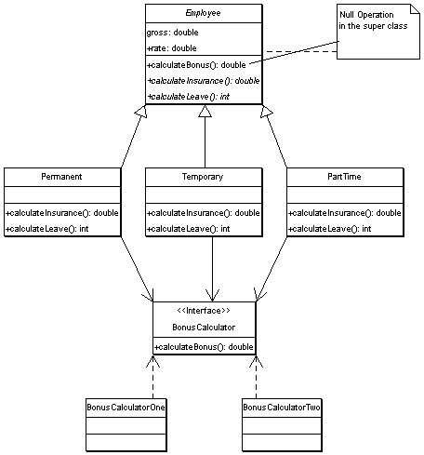
Figure 2: The CRP based Employee class hierarchy
The diagram above demonstrates that the BonusCalculator is a composite of all the different Employee classes, and thus an extremely flexible polymorphism has been achieved. The algorithm can be changed at any time for bonus calculation by attaching a different implementation of the BonusCalculator to any of the Employee objects.
This is where Composition is a superior choice. Inheritance ties you to a particular implementation or forces you to give up the original idea of generalization by having to constantly override the super-class methods in each sub-class. This is, however, not exactly a limitation of inheritance but more of an issue with how the inheritance is applied. As you gain experience, you will find that utilizing CRP is a safer approach.

Putting Design Principles to the Test
(A Java based Case Study)
by: Samudra Gumpta
It's time to consolidate on what we've been discussing in this series about design principles governing the class structure and package structure. In this article, I will present a sample case study in which we will develop a hypothetical application component and try to employ all the design principles we have learned so far, to come up with a reasonable robust design solution. You can appreciate that it is well beyond the scope of the space for this article to present a large-scale project architecture encompassing all the complexities that can arise in a designing situation. So, I will try to pick a hypothetical application component and try to present a design for that component module. Well then, have your cup of coffee ready with you.

Reprise of what we have discussed
In the previous five articles, I have presented the design principles governing the class structure and packaging of several classes into different packages. In this section, we will recapitulate the principles that we have discussed so far.

Design Principles for Class Structure
Principle 1: Open Closed Principle (OCP)
A software module should be closed for modification but open for extension.
Principle 2: Liskov’s Substitution Principle (LSP)
If for each object o1 of type S there is an object o2 of type T such that for all programs P defined in terms of T, the behavior of P is unchanged when o1 is substituted for o2 then S is a subtype of T.
Principle 3: Dependency Inversion Principle (DIP)
- High-level modules should not depend upon low-level modules. Both should depend upon abstractions.
- Abstractions should not depend upon details. Details should depend upon abstractions.
Principle 4: Composite Reuse Principle (CRP)
Favor composition over inheritance to achieve polymorphism.
Principle 5: Interface Segregation Principle (ISP)
Many specific interfaces are better than one combined general interface.

Design Principles for Package Structure
Principle 1: Release Reuse Equivalency Principle (REP)
The granule of release is the granule of reuse.
Principle 2: Common Reuse Principle (CReP)
The classes in a package are reused together. If one of the classes in a package is reused, all the classes in that package are reused.
Principle 3: Common Closure Principle (CCP)
Classes that change together must be placed in the same package.
Principle 4: Acyclic Dependency Principle (ADP)
The dependencies between packages must form no cycles.
Principle 5: Stable Dependencies Principle (SDP)
The dependencies between packages must always be in the direction of stability. Less stable packages should depend on more stable packages.
Principle 6: Stable Abstraction Principle (SAP)
The stable packages must be abstract packages. The instable packages should contain the concrete implementations.

A Sample ReportWriter Component Case Study
Now that we have recapitulated the principles that we need to keep in mind while designing any component, let us venture to design such a component. For example, let us think that we need to develop a Reporting component. This component in short needs to support the following features:
- It will accept the criteria for producing any report.
- Against a set of valid criteria, it will fetch the data from a data source and produce the report in a desired format.
I would at this point try to avoid any detailed discussion of any other possible features that the ReportWriter component might provide.

Business Type Model
With these features in mind, we can develop a sample Business Type Model (BTM) for our ReportWriter component. This sample BTM is presented in Figure 1.
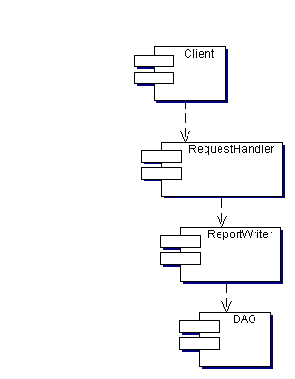
Figure 1: The Business Type Model for the ReportWriter component
This BTM shows the different components acting together to produce the report. The Client component makes a report request to the RequestHandler component. The RequestHandler component then makes a call to the ReportWriter component supplying the report parameters to it. The ReportWriter component then makes use of DAO component to obtain the data from a specific data source, produces the report and hands it over to the RequestHandler component to send it back to the appropriate client.

Designing the Classes
Once we have the BTM with us, it is time to get into the real class structure. Deciding on the class structure is often an iterative process. The initial design may get affected with slight requirement change or changes in the existing components that the component in question is going to use. In this context, the challenge is to come up with a design, which is flexible enough to accommodate such changes.
Well then, lets proceed with designing the classes for our ReportWriter component. First of all, let us consider the entry point to the ReportWriter component. A Client makes a request to the ReportWriter. We need a mechanism to handle this request. If you are developing a web-based application, this request will typically be over HTTP. So, we need to have a mechanism to handle the HTTP requests. In Java world, this is handled by using a Servlet.

Designing the RequestHandler
So our initial class diagram for RequestHandler might look like something in Figure 2.
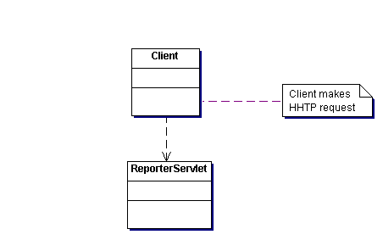
Figure 2: The class diagram for handling the client request
At this point it is clear that the client makes a HTTP call to the ReporterServlet requesting to produce a report. In other situations, a Client can interact with the ReportWriter component using some other protocols such as RMI etc. We will see later in the series how to best accommodate such scenarios. But whatever be the protocol, the RequestHandler component will ultimately make use of the ReportWriter component to produce the report.

Designing the ReportWriter
Now we come to the main bit of the application i.e. designing the ReportWriter component. The following points are important to note:
- The format of reports can vary from client to client. For example, one client may request an HTML report while another may be looking for an Excel based report.
- To produce each individual report format, we might need to implement different technologies. For example, while HTML formatted reports are easy to produce; Excel reports may be little more complicated.
- We need to come up with a design so that the change in underlying implementation of ReportWriter will not affect the client code in any form.
Figure 3 represents a possible solution based on the idea that client at the moment requires two types of reports: HTML and Excel.
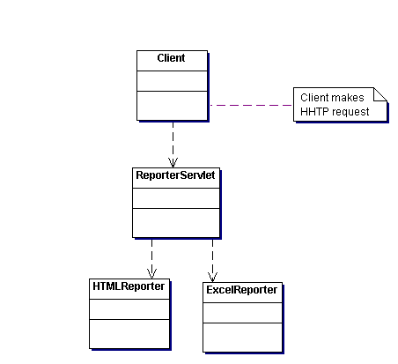
Figure 3: One possible class structure for the ReportWriter component
Although this is a possible solution, this is not a good one. We now try to test if this design passes all the principles stated in the Class Designing principles previously.

Testing against OCP
What if we need to add another type of reporting say PDFReporter? Obviously, as ReporterServlet needs to be altered in order to accommodate this third type of reporting capability. Worse is the case, if we don’t want one of the existing type of report any more. Even then, we need to go back to the ReporterServlet and accommodate the change. Clearly, this is against OCP. This design is not closed for modification and is not open for extension.

OCP compliance
Clearly, the solution is to make the ReporterServlet depend on an abstraction of the ReportWriter. This way, the underlying implementation will not affect the ReporterServlet code to change. The design in Figure 4 is OCP compliant solution:
The classes in a package are reused together. If you use one of the classes in a package, you reuse all the classes in that package.
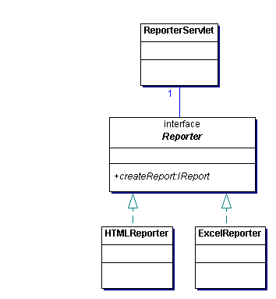
Figure 4: The OCP compliant design for the ReportWriter component

Test against DIP
The design in Figure 4 is OCP compliant and also maintains the principle of Dependency Inversion. Previously, the high-level module the ReporterServlet had a strong coupling with the concrete implementation of the individual Reporter. Now both the high-level module and the low-level XXXReporter implementations depend on the abstraction viz. Reporter interface.

Designing the Data Access Objects
The ReportWriter component needs to bring back data from a certain data source. Typically, it may be a database. One possible solution to the problem of bringing back the data from any data source is to write a separate Data Access Object component. The DAO component receives the criteria from the ReportWriter component for bringing the data back, fetches the data back from the data source and returns the data back to the caller ReportWriter component. Figure 5 represents a possible solution with a DAO bringing back data from database.
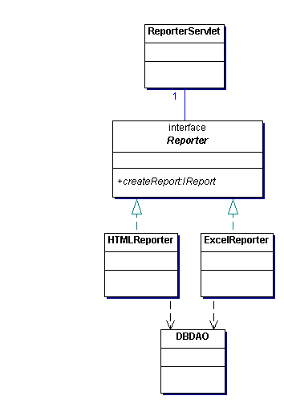
Figure 5: One possible solution for Reporter objects to bring data from database.

Test against OCP
Again this solution fails to clear OCP test. We have lost the flexibility to bring data from any data source other than Database. Of course, we can implement another DAO to bring back data from say flat file, but that means we need to go back to the Reporter objects and change the strong coupling with the DBDAO to use the new DAO. Clearly, the solution is that the Reporter objects should depend on some abstraction of the DAO classes.

Test against DIP
The test against Dependency Inversion Principle also fails as in the previous design the high-level modules (ReportWriter objects) directly depend on the low-level modules (DAO objects). The DIP dictates that both should depend on abstraction.

The correct solution
Figure 6 represents the correct solution for the relationship between ReportWriter objects and the DAO objects.
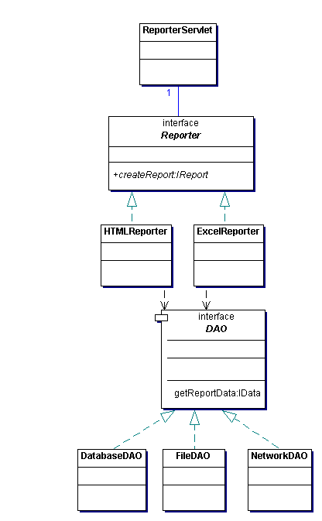
Figure 6. The correct relationship between ReportWriter component and DAO component
This solution offers much more flexibility as you can see that we have easily attached two more DAOs to the previous solution.

Designing the Formatter for the Reporter
Now we have data to produce the report. One more thing, we need is to format the report in a desired way. One possible solution is to have separate Formatter objects. Again thinking in the line of OCP and DIP, we want to come up with an interface based solution for the Formatter objects so that we can interchange the format of reports without having to change the ReportWriter objects.
Figure 7 represents the design by incorporating the Formatter interface.
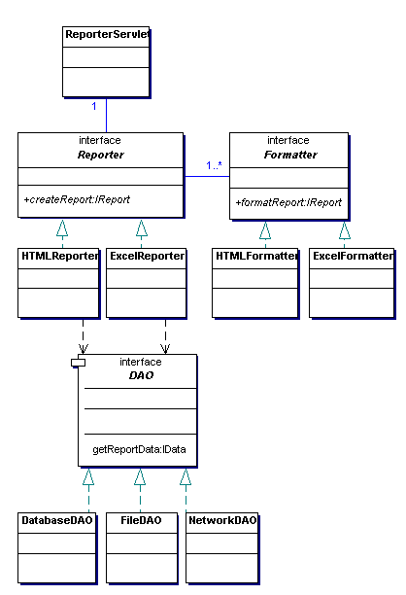
Figure 7: The design incorporating Formatter objects

Conclusion
You can now see that we have a reasonable design for the ReportWriter component. This design is extendible and OCP compliant. Now it is time to finalize the interaction mechanism among the components. The questions that we need to ask is how each component will make use of one out of the many implementations of any particular abstraction (interface) and also how different components will exchange data amongst themselves.

Putting Design Principles to Test – Part 2
Welcome back to our series on design principles. If you recall we have been discussing a hypothetical case study for developing a reporting component. You would think that at this time we would talk about how to write the classes and interfaces for the reporting component, but there is still more we need to focus on to finalize our design.
First, let's look at this class diagram (Figure 1) that we ended with in the last article.

Things have changed since then…
Since we came up with this design, a month has elapsed. We all know that this is too long a time scale in the world of programming. We now come back to the class diagram, but there is a new requirement regarding the HTML formatter reports. One of your managers has come up with a new idea (they always do!!!). If there is tabular data and the number of rows is more than 25, he wants a scrollable table (damn!). Thinking about it for a little while, you see a ray of hope; there is a browser incompatibility issue that Netscape might not support this wonderful scrollable table idea. So in your opinion, it is better to come up with a solution that is liked by both the browsers IE and Netscape.
You set out for the manager’s room and explain everything. He nods and smiles and then says "OK, we then need to capture which browser the user is currently using and depending on that we either display plain table or scrollable table". You return back with an added layer of complexity. Don’t be too disappointed; it is after all simply a matter of writing another Formatter object.

Things look better…
Ok, we already have an HTMLFormatter class with us realizing the interface IFormatter. Now we need to come up with a new class to format the scrolling table. Let us name this class as MsHTMLFormatter (as this implements features supported by MSIE only). So we decide to come up with a class design something like this (Figure 2):
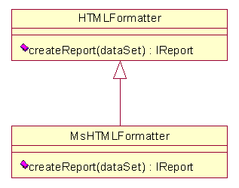
Figure 2: The class relationship diagram with new MsHTMLFormatter

Things are deceptive…
This design isn't as righteous as it seems from the surface, it is wrong. How could we get it wrong, when we had been learning all the design principles for so long? Well, the answer is we did not follow the design methodology before we designed the MsHTMLFormatter.
One rule of thumb to me is whenever I decide to subclass any existing class; I follow the design by contract principle. To do that, we just need to jot down the pre and post conditions for the super class and the sub class. Figure 3, represents the design by contract for the HTMLFormatter and MsHTMLFormatter classes.
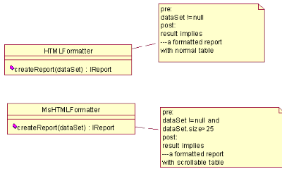
Figure 3: Design by Contract for MsHTMLFormatter
Inspect the contracts ,the pre-conditions and the post-conditions specified in both the classes. Clearly, the subclass MsHTMLFormatter has more of a number of pre-conditions than its super-class HTMLFormatter. Now recall, the Liskov’s Substitution Principle (LSP), we discussed in the beginning of the series.
It reads: If a program P is using a super class S and sub class T exists for the S, then the program P should retain the same behavior of S is substituted by T.
In our case, let us assume that our Reporter programs (P) uses an instance of the HTMLFormatter (S). MsHTMLFormatter (T) is a sub class of the HTMLFormatter (S). According to LSP, we should be able to substitute any use of HTMLFormatter with MsHTMLFormatter without the behavior of program P getting changed.
Clearly, in our design it is not going to happen that way. Imagine, we are working with a data set of size 5. If we are using the HTMLFormatter, this data set will be processed and formatted. The moment we replace the HTMLFormatter instance with MsHTMLFormatter, it will break because MsHTMLFormatter will not format the data set if the size of the data set is less than 25.
This indicates that the hierarchy we created with HTMLFormatter and MsHTMLFormatter is wrong. To conform to LSP, they should both inherit from one abstraction. Figure 4 represents the correct design:
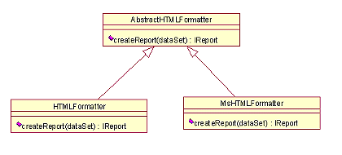
Figure 4: The correct LSP compliant solution

Let us package them…
Well, we have now got our Reporter objects, Formatter objects and Data Access Objects all in place. The hierarchy looks reasonably done and the good news is that they conform to design principles, but surely all of these classes cannot reside in the same package and we need to come up with a package structure for these classes.
One good idea for package structure is to place the interfaces and the concrete implementations in a separate package. This enables us to achieve a complete separation of the specification and the realization of the component/modules we are developing. Keeping this is mind, we can draw an initial package diagram as shown in Figure 5.
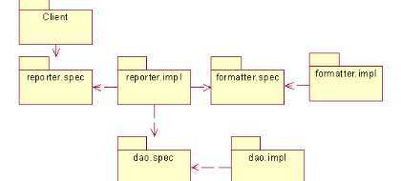
Figure 5: The initial package diagram for the reporter module
As you can see from this package diagram, the whole module has got four separate components. The first is Client component, the second the Reporter component, the third the Formatter component and the fourth and last is the Data component.
The importance of the package relationship diagram is to check whether the dependencies are in the right order and right direction.

Stable Dependencies Principle (SDP)
From our package diagram in Figure 5, it is clear that packages do depend on each other. Careful attention will also reveal that each component depends on the abstraction (specification) package of the other component. This ensures that direction of dependencies is towards the stable packages. This is because the specification is less likely to change compared to the implementation.

Stable Abstraction Principle (SAP)
In the last series when I discussed about the SAP, I provided a formula for calculating the stability index of a package based on the incoming and outgoing dependencies of the individual package. Accordingly, for our trivial example, we will note down the incoming and outgoing dependencies of each package
The formula for calculating the Stability Index I is:
I =Outgoing/(outgoing+incoming)
Package | Incoming | Outgoing | Stability Index
Client | 0 | 1 | 1/(1+0) = 1
reporter.spec | 2 | 0 | 0/(0+2) = 0
reporter.impl | 0 | 3 | 3/(3+0) = 1
formatter.spec | 2 | 0 | 0/(0+2) = 0
formatter.impl | 0 | 1 | 1/(1+0) = 1
dao.spec | 2 | 0 | 0/(0+2) = 0
dao.impl | 0 | 1 | 1/(1+0) = 1
Table 1: The stability index for all the packages
In the discussion of SAP, we also saw that if the Stability index is nearing 1, then it is a less stable package and if the Stability index is nearing 0, it is a more stable package.
From our table, we can see that the specification packages (e.g. reporter.spec) have Stability index 0 where as the implementation packages (e.g. formatter.impl) have Stability index 1. This implies that the specification packages are more stable than the implementation packages. This is a correct design. It is also to note that our package dependencies are in the direction of stable packages as packages depend on each other via the specification packages.
Thus, our design conforms to the Stable Abstraction Principle.
Note: This example is a very trivial one. In real world, it is hardly possible to design a package with Stability index equal to 0 or 1. As the number of dependencies grows, they tend to assume a more fractional value. For example, if say the dao.spec package depends on java.sql package, then the Stability index will change to 1/(1+2) = 0.33. Still it is toward the 0 value and thereby tends to be a stable package.

We need some utility tools…
One thing is sure, that if we keep on refining the design forever, the project is going to miss the deadline. One fundamental concept of today’s modern development methodologies such as Rational Unified Process (RUP) is that they rely on iteration. It is good practice to accept that things have a natural course of evolution and any system and for that matter any design will need to go through iteration.
So once we have a reasonable design at our disposal, we must start implementation. While we are in this process, all of a sudden we realize that we now need some utility functions such as putting header and footer for all the formatted report data. As we are now mature developers, we know that it will be a good practice to place these utility functions in a separate class. Let us for the time being call this class ReportUtility. We also thought that as this is a report utility, we would place the ReportUtility class in the reporter.util package.
As time goes by we start implementing one of the Formatter classes and realize that this particular Formatter object will require putting some heading into the formatted report. We turn our attention towards the ReportUtility class and discover to our joy that there is a method to do just such a job. So we happily use it from within our Formatter class.
The code works but unknowingly we have introduced a problem. To understand the problem, we will redraw the package diagram, this time, in a different way in Figure 6.
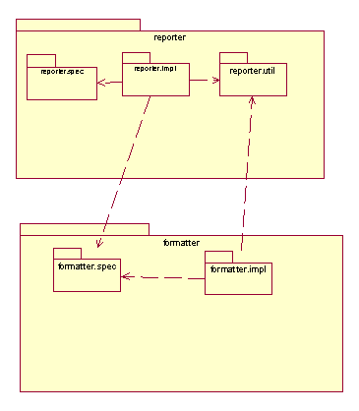
Figure 6: The package diagram with the utility package.
What you notice here is a problem of Cyclic Dependency between the packages reporter and formatter. The problem arises because one of the classes from the formatter package is willing to use classes from the reporter package.
Don’t be discouraged. This happens and it can be avoided with experience and adhering to the design methodologies and by checking the design at a regular time period. You know how to solve this cyclic dependency by factoring out the class to a different package or by placing it in the formatter package. The reporter package can still continue to use the utility classes as it already depends on the formatter package.

Conclusion
This brings us to the end of our example design. A larger example, would simply be too complicated to present. I hope this simple example will help you grasp the concepts and will have you applying them in your own designs.
I have received many emails from readers who liked the topics I have discussed so far. I'd like to say thanks to all of you, and as always it is good to hear from the readers. Please e-mail with particular topics you'd like me to cover and I'll try to get to them all. With this I say good-bye to this series. Till I come back next time, happy-coding.

